**Use Fab-Speed-Dial Dependences To create Awesome Action button.**

**“Reference:** <https://github.com/yavski/fab-speed-dial>**”**

1. Add these two dependency in

Gradle Script > build.gradle(Module:app) in the dependencies section

// custom Library  
implementation 'io.github.yavski:fab-speed-dial:1.0.6'  
//noinspection GradleCompatible  
implementation 'com.android.support:design:25.3.1'

1. Sync/build your project again.
2. Create a menu repository in res folder . create a menu_1 filein menu repository which contain three item with different **icons** and id.

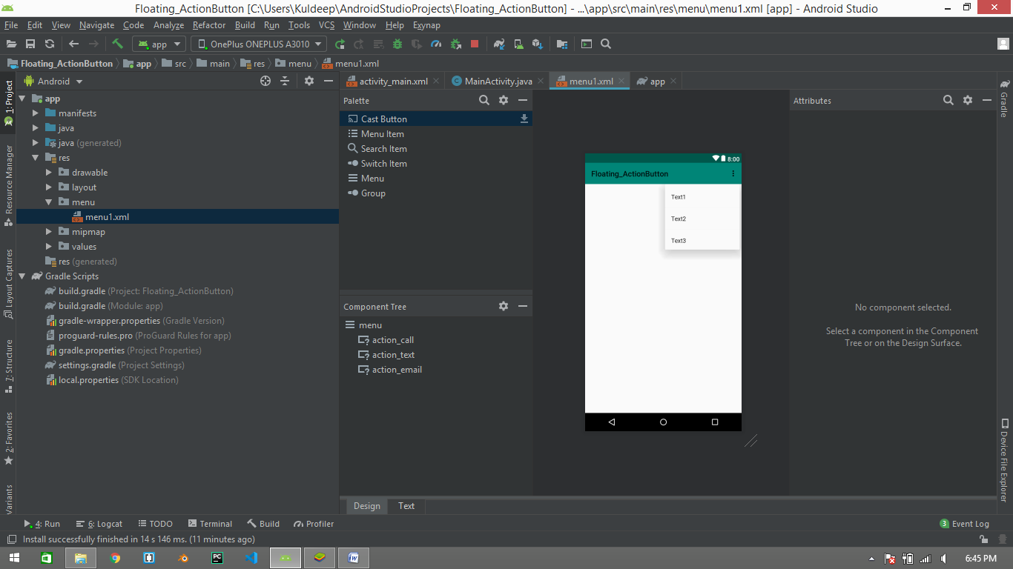

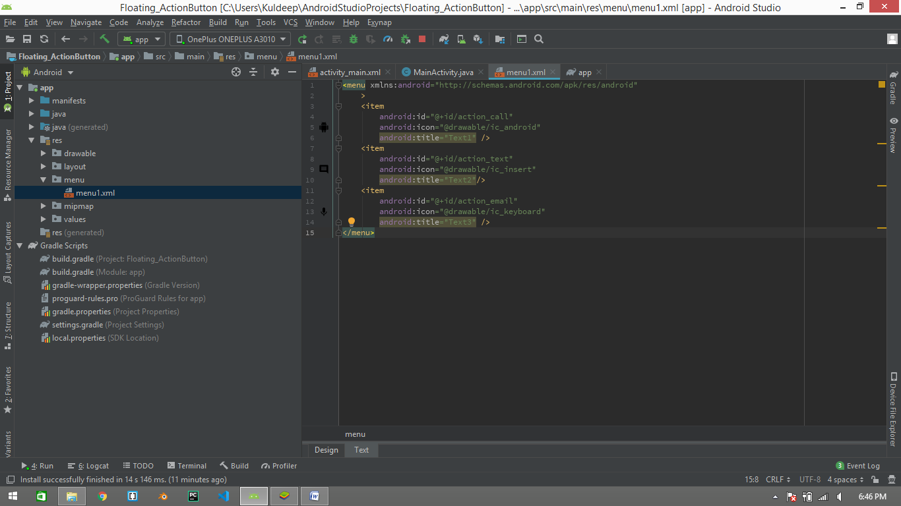

1. In **mainActivity.xml** file ,follow below steps:-

<?xml version="1.0" encoding="utf-8"?>  
<FrameLayout xmlns:android="http://schemas.android.com/apk/res/android"  
 xmlns:app="http://schemas.android.com/apk/res-auto"  
 xmlns:tools="http://schemas.android.com/tools"  
 android:layout_width="match_parent"  
 android:layout_height="match_parent"  
 android:padding="16dp"  
 tools:context=".MainActivity">  
  
 <io.github.yavski.fabspeeddial.FabSpeedDial  
 android:id="@+id/fab_1"  
 android:layout_height="wrap_content"  
 android:layout_width="wrap_content"  
 android:layout_gravity="bottom|end"  
 app:fabGravity="bottom_end"  
 app:fabMenu="@menu/menu1"  
 app:miniFabBackgroundTint="@android:color/white"  
 app:miniFabDrawableTint="@android:color/holo_blue_light"  
 app:miniFabTitleTextColor="@android:color/black"  
 />  
  
</FrameLayout>

1. And in mainActivity.java file , follow below code of lines:-

public class MainActivity extends AppCompatActivity {  
  
 @Override  
 protected void onCreate(Bundle savedInstanceState) {  
 super.onCreate(savedInstanceState);  
 setContentView(R.layout.*activity_main*);  
  
 FabSpeedDial fabSpeedDial = (FabSpeedDial)findViewById(R.id.*fab_1*);  
 fabSpeedDial.setMenuListener(new FabSpeedDial.MenuListener() {  
 @Override  
 public boolean onPrepareMenu(NavigationMenu navigationMenu) {  
 return true;  
 }  
  
 @Override  
 public boolean onMenuItemSelected(MenuItem menuItem) {  
 Toast.*makeText*(MainActivity.this,""+menuItem.getTitle(),Toast.*LENGTH_SHORT*).show();  
 return true;  
 }  
  
 @Override  
 public void onMenuClosed() {  
  
 }  
 });  
 }  
  
}

1. Run Your resource File.

